WANT TO WIN TICKETS TO A SABRES GAME?
THE ORCHARD PARK VOICE
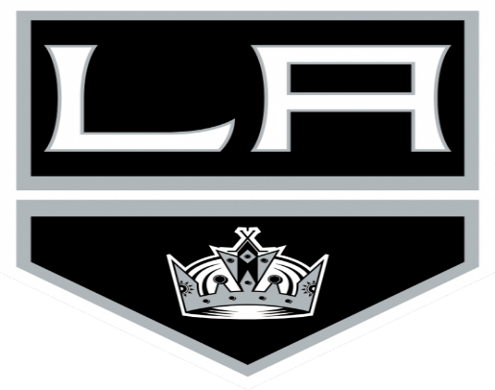

VS.

Saturday, February 17, 2018 @ 1 P.M.

WRITE AN ARTICLE AND SUBMIT FOR A CHANCE TO WIN!

MORE INFORMATION AVAILABLE OUTSIDE ROOM 316!

